A STUDY TOUR TO VIETNAM
January 4-14, 2024

Exploring natural wonders, cultural events, Vietnam’s history, its traditions, and pluralistic religions. The tour will begin from Saigon, the south of Vietnam, to My Tho, Danang city, Hoi An, Hue, Hanoi, Ninh Binh, and Ha Long bay.

Day 1 (01/04/2024): Washington-Vietnam
In the morning (EST), take the flight from a Washington DC area's airport to Vietnam.

Day 2 (01/05/2024): Arrival in Saigon City
Connecting flight in an Asian country and arriving in Saigon city.
Welcome and stay overnight in Saigon.

Day 3 (01/06/2024): Mekong Delta- Vinh Long Homestay (breakfast, lunch and dinner)
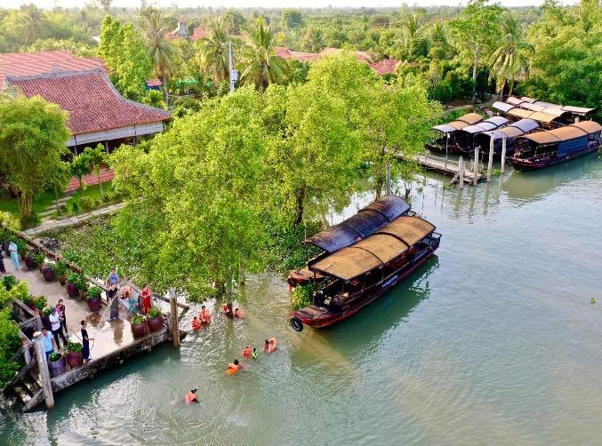
Breakfast at hotel.
Depart in the morning to Cai Be tourist harbor. Then, You come to Tân Phong island for biking /walking on village paths to see the local daily life: orchard, school, church, pagoda, traditional houses. On the way, we can make some stops to see how they wave the dried water-hyacinth to make many products: baskets, bags, hats, wallets, shoes, stop at local garden enjoy some cups of tea when listening to the traditional music .
Then, the rowing boat will take you deeper into the countryside on smaller canals to enjoy the peaceful time. Lunch can be served at homestay.
After lunch, check in at Út Trinh / Út Quỳnh / Út Bình homestay. Have biking trip around the local village.
Have a fresh shower before cooking some special dishes with the members of local family. We’ll enjoy dinner & Overnight at homestay.

Day 04 (01/07/2024): Vinh Long- Saigon City (Breakfast, lunch and dinner)
Have a breakfast and check-out for a walk along the village to enjoy the fresh air in the morning & arrive the local workshop to see how to make rice paper, coconut candy, pop- rice... Enjoy some sweets with a cup of hot tea.
Boat trip to visit the brick kilns where you can see how the local people create beautiful potteries from clay. Our boat will go along the floating village. We will see how to farm catfish on Mekong river.
Also, we can visit Vinh Long market in the town. This is the best choice for you to take pictures of fish, shrimps, prawns, crabs, rice-field rats, tropical fruits, vegetables... Return to Vinh Long boat station. Back to Saigon City.
Ovenight in Hotel.

Day 05 (01/08/2024): Saigon Tour-Immersion experience
Have breakfast at Hotel. Start the trip to:
- Saigon - Visiting the former Presidential Palace and a Blind school. After lunch, city tour to visit:
- Notre Dame Cathedral – a French-built cathedral occupies scenic Paris Square in the heart of Saigon city.
- Saigon Old Post Office - The Central Post Office has long become a prominent feature of Saigon.
- Ben Thanh market, then lunch
Visit an orphan house/center of charity. Dinner with music entertainment on a cruise.

Day 06 (01/09/2024): Saigon- Dong Hoi, Phong Nha Cave (B,L,D)
Morning: Transfer to Tan Son Nhat airport for the flight to Dong Hoi, Quang Binh
Arrival to Quang Binh. Have lunch and depart to Phong Nha Cave ,
Transfer to Xuan Son ferry and take a boat trip on the Son river to Phong Nha Cave and star exploring Phong Nha Cave. An immortal place with some shape of the beautiful stalagmites and listed in UNESCO’s World Heritage Sites in 2023.

Day 07 (01/10/2024): | Quang Binh- Hue City (B,L,D)
After breakfast at hotel, depart to Hue City. Have lunch at Hue and start excusion at:
- Imperial Citadel: the forbidden city- royal capital of Nguyen dynasty of Vietnam.
- Khai Dinh King tomb - the most beautiful of Hue’s royal mausoleum.
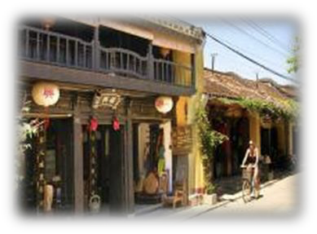
- Overnight in Hue
Day 08 (01/11/2024): Hue-Da Nang-Hoi An Ancient Town (all three meals)
After breakfast in hotel. Transfer to Danang.
- Arrive in Danang,
- Son Tra Peninsula with famous Lady Statue Buddha
- Marble Mountain: The five 'mountains' are named after the five foundational elements: metal, water, wood, fire, earth.
- Cham sculpture museum: The majority of Champa's sculptures from the 12th to the 15th century is made of sandstone with different art styles. Check out room. Have lunch.
- My Son Holy Land: My Son is a center for spirituality and worship during the reign of the Champa Kingdom.

Transfer to Hoi An
Move to the theme park to have dinner and enjoy the show majestic and splendid Hoi An memories.
Overnight in Hoi An.

Day 09 (01/12/2024): HOI AN– HANOI (All three meals)
Breakfast at hotel.
Hoi An Ancient town – UNESCO World Cultural Heritage site: Hoi An exudes many charms. This quaint heritage town is often the highlight of every visitor’s itinerary. Steeped in traditional architecture, yet cosmopolitan in nature, a stroll through the old quarter is an essential experience.
Gourmand restaurants, boutique clothes shops, art galleries, tailors and shoemakers abound in this ancient trading port town. Hoi An also boasts beautiful beaches and a romantic countryside abundant in rice paddy fields.
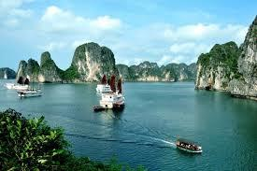
Transfer to airport for the flight to HA NOI. Overnight in Hanoi.
Day 10 (01/13/2024) | : HANOI CITY-HA LONG BAY (B, L, D | )
Breakfast at hotel.
We travel to Ha Long Bay, a World Heritage Area of natural wonder. “Dragon descending to the sea” as it is known in Vietnamese. Picturesque Ha Long Bay has more than 1.000 limestone islets rising from the sea, many of them containing beautiful grottoes.
Upon arrival at Ha Long Bay, we embark on a boat trip to cruise discovering this magnificent UNESCO World Wonder. This is a great journey among surreal islands rising from a tranquil emerald sea.
Enjoy a delicious seafood dinner on board as the boat cruises towards South East Halong Bay, passing by beautiful stalactites and stalagmites.

The boat heads back to harbor and disembarking at Tuan Chau Marina harbor.
Back to Hanoi city. Dinner and overnight in Hanoi.

Day 11 (14/1/2024): Hanoi (All three meals)
After breakfast. Car and tour guide pick and transfer to visit:
- Free at leisure or shopping in the morning.
- Temple of Literature - Vietnam’s first university constructed in 1070
- Hoan Kiem Lake - was already considered the most beautiful lake in Hanoi
- Ngoc Son Temple - A temple on the island of Ngoc Hoan Kiem Lake, Hanoi, built in the 19th century.
- Visit and attend the mass at Hanoi Cathedral – St. Joseph and Saint Joseph Seminary of Hanoi.
- Dinner at restaurant.
After that, transfer to Noi Bai airport for the flight back to Washington DC. End of service!

Cost: $2000 ground + $1800 international round trip flight (if reasonable schedules are not available at this rate at the time of booking, there will be an increase in the total fee)
Including | Excluding
- Accommodation 3 stars shared in double/twin with daily breakfast.  - All transfers and sightseeing stated in program by private air-conditioned transportation.  - 17 meals as indicated.  - English speaking guide.  - All entrance fees as listed.  - Mineral water (2 bottle, 2 tissues/person/day)  - Visa fees and personal travel insurance  - International air tickets in Vietnam and airport taxes. | - Meals & drink other than specified in the itinerary  - Surcharge for single room  - Other personal expenses not mentioned nor specified in the tour program  - Tips for Guiders and Drivers
Surcharge for air ticket (Quote seperately)
International flight: $1800/ person for round trip from IAD or BWI to Saigon
Domestic flights: From Tan Son Nhat airport in Saigon to Dong Hoi airport and from Hue airport to Noi Bai airport in Hanoi.
Note: the tickets' prices can change depending on the rate of tour time when booking.

Accommodation 3 star with daily breakfast
- Saigon city: Ambassador Saigon Hotel or similar
- Da Nang: Dyland Hotel or similar
- Hoi An: Sunshine Hotel or similar
- Hue: Jasmine Hotel or similar
- Hanoi: Hanoi Amanda Hotel or similar
- Ninh Binh: Hoa Lư Hotel or similar

LOYOLA 2024 STUDY TOUR TO VIETNAM

Application

I understand that I am not committed to the trip until I pay the trip deposit ($ 500 – Cost of this trip: $ 3,300 (see details with itinerary)). MAKE CHECKS PAYABLE TO: LOYOLA UNIVERSITY MARYLAND

Travel Dates: January 4 to January 14, 2024

DEADLINE AND FINAL due by October 30, 2023

Participant #1

Name: Last ______________________________
First______________________________
Middle____________________________
Gender/Gender Identity______________
Address:_________________________________
City:_______________State:______Zip:_______
Cell Phone: ( )__________________________
Email Address:____________________________
Passport #:_______________________________
Date Issued:________ Date Expires:___________
Date of Birth: ______________________
Place of Birth:__________Citizenship:_________
Loyola Graduation Year (if applicable):________
Will other travelers join you on this trip? (friend, family, spouse, etc.): Yes ___ No/Not sure ___

Participant #2

Name: Last ______________________________
First______________________________
Middle____________________________
Gender/Gender Identity______________
Address:_________________________________
City:_______________State:______Zip:_______
Cell Phone: ( )__________________________
Email Address:____________________________
Passport #:_______________________________
Date Issued:________ Date Expires:___________
Date of Birth: ______________________
Place of Birth:__________Citizenship:_________
Loyola Graduation Year (if applicable):_______

DEPOSIT:____________($500) FULLPAYMENT:________ (Full $3,300)

Signature Participant #1_______________________________________DATE_____________________

Signature Participant #2_______________________________________DATE_____________________

Please return this application with the checks and copy of your passport to:
Fr. Bao Nguyen, S.J., Ph.D.
bqnguyen@loyola.edu
Tel: (410)617-7088

